What does web server do?

Server is receiving request from user and check requested resource file and find it and write it in the response object and send it back to user.

What does web browser do?

Browser sends the request to server and receives the response from and render page in the window.

HTML and Web pages

It is a Markup language for creating static web pages and keeps it on server machine. When user is requesting the page from server, server will find it and distribute the page to client.

Communication between Web server and Web Browser

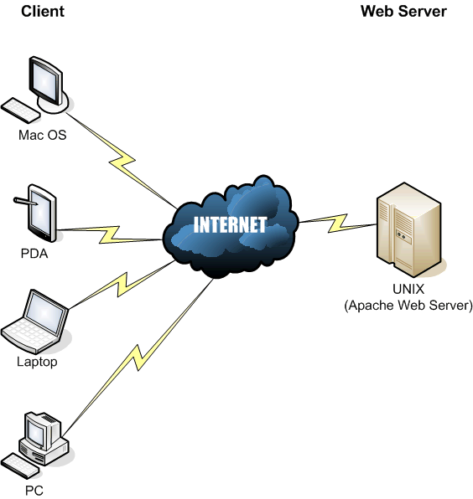

HTTP Protocols

Web browser and Web server can be communicated by using HTTP protocols.

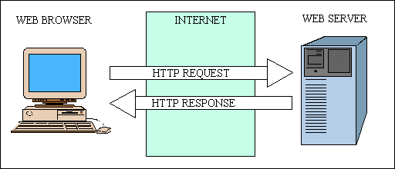

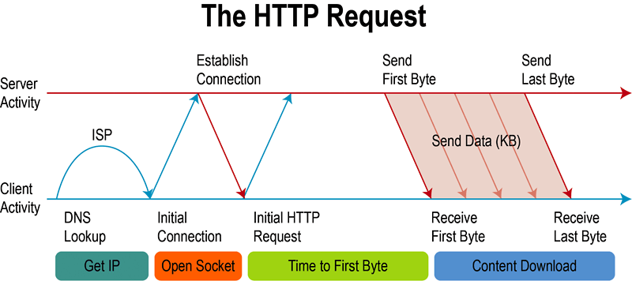

DATA IN HTTP RESPONSE

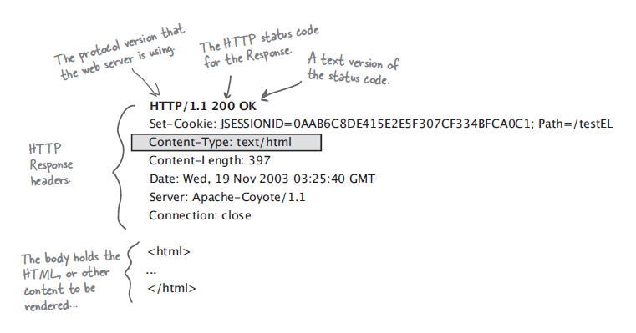

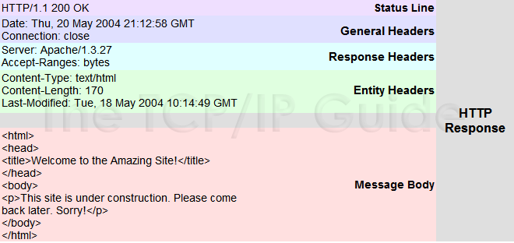

Header | Description
Allow | This header specifies the request methods (GET, POST, etc.) that the server supports.
Cache-Control | This header specifies the circumstances in which the response document can safely be cached. It can have values public, private or no-cache etc. Public means document is cacheable, Private means document is for a single user and can only be stored in private (non shared) caches and no-cache means document should never be cached.
Connection | This header instructs the browser whether to use persistent in HTTP connections or not. A value of close instructs the browser not to use persistent HTTP connections and keep-alive means using persistent connections.
Content-Disposition | This header lets you request that the browser ask the user to save the response to disk in a file of the given name.
Content-Encoding | This header specifies the way in which the page was encoded during transmission.
Content-Language | This header signifies the language in which the document is written. For example en, en-us, ru, etc.
Content-Length | This header indicates the number of bytes in the response. This information is needed only if the browser is using a persistent (keep-alive) HTTP connection.
Content-Type | This header gives the MIME (Multipurpose Internet Mail Extension) type of the response document.
Expires | This header specifies the time at which the content should be considered out-of-date and thus no longer be cached.
Last-Modified | This header indicates when the document was last changed. The client can then cache the document and supply a date by an If-Modified-Since request header in later requests.
Location | This header should be included with all responses that have a status code in the 300s. This notifies the browser of the document address. The browser automatically reconnects to this location and retrieves the new document.
Refresh | This header specifies how soon the browser should ask for an updated page. You can specify time in number of seconds after which a page would be refreshed.
Retry-After | This header can be used in conjunction with a 503 (Service Unavailable) response to tell the client how soon it can repeat its request.
Set-Cookie | This header specifies a cookie associated with the page.

DATA IN HTTP REQUEST
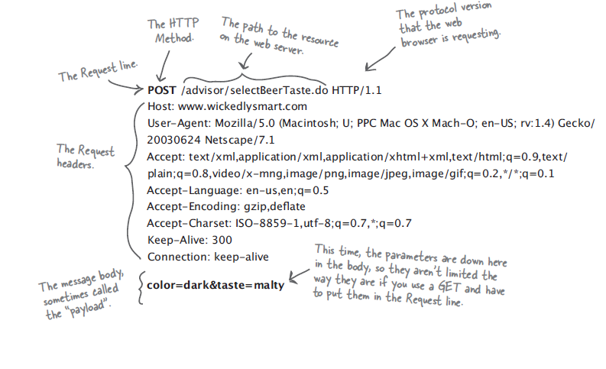

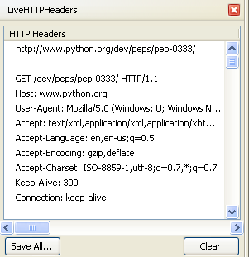

Header | Description
Accept | This header specifies the MIME types that the browser or other clients can handle. Values of image/png or image/jpeg are the two most common possibilities.
Accept-Charset | This header specifies the character sets the browser can use to display the information. For example ISO-8859-1.
Accept-Encoding | This header specifies the types of encodings that the browser knows how to handle. Values of gzip or compress are the two most common possibilities.
Accept-Language | This header specifies the client's preferred languages in case the servlet can produce results in more than one language. For example en, en-us, ru, etc.
Authorization | This header is used by clients to identify themselves when accessing password-protected Web pages.
Connection | This header indicates whether the client can handle persistent HTTP connections. Persistent connections permit the client or other browser to retrieve multiple files with a single request. A value of Keep-Alive means that persistent connections should be used
Content-Length | This header is applicable only to POST requests and gives the size of the POST data in bytes.
Cookie | This header returns cookies to servers that previously sent them to the browser.
Host | This header specifies the host and port as given in the original URL.
If-Modified-Since | This header indicates that the client wants the page only if it has been changed after the specified date. The server sends a code, 304 which means Not Modified header if no newer result is available.
If-Unmodified-Since | This header is the reverse of If-Modified-Since; it specifies that the operation should succeed only if the document is older than the specified date.
Referer | This header indicates the URL of the referring Web page. For example, if you are at Web page 1 and click on a link to Web page 2, the URL of Web page 1 is included in the Referer header when the browser requests Web page 2.
User-Agent | This header identifies the browser or other client making the request and can be used to return different content to different types of browsers.

Type of Requests

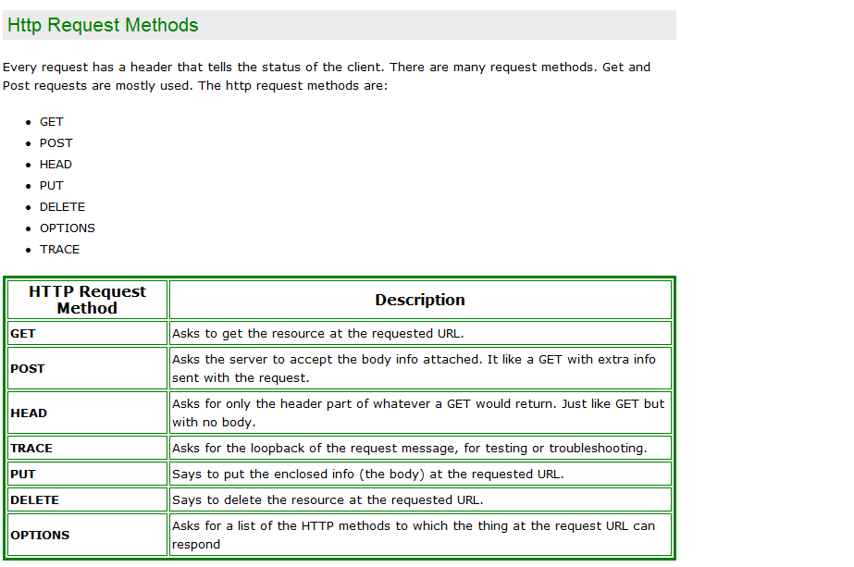

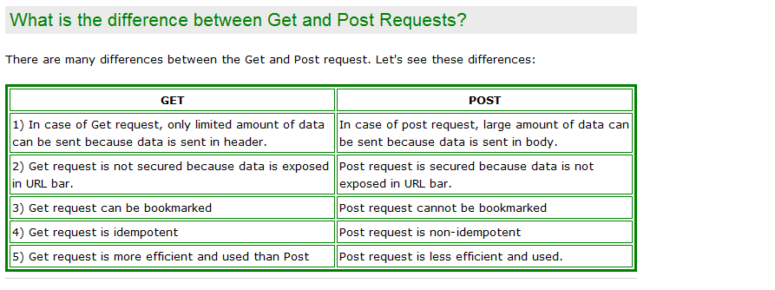

Protocols Layer

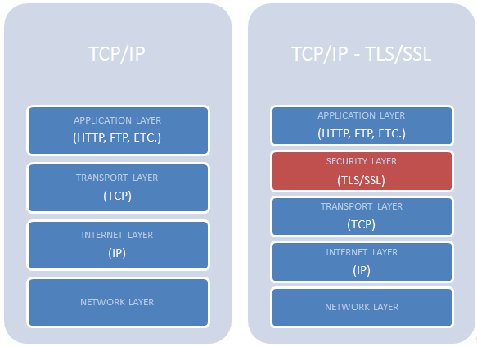

URL Address

http://localhost:8080/online/home.html

http:// - protocol name
localhost - IP Address of server Machine
8080 - Port Number of the Application
Online/home.html – resource path

Page Navigation

We have to create Hyperlinks in HTML page to navigate the users from one page to another page.

In that hyperlinks we need to give location of the page to be requested when user clicks on links.

Path can be two types:
- Absolute path –always begin with / symbol
- Relative Path

Sample Demo:

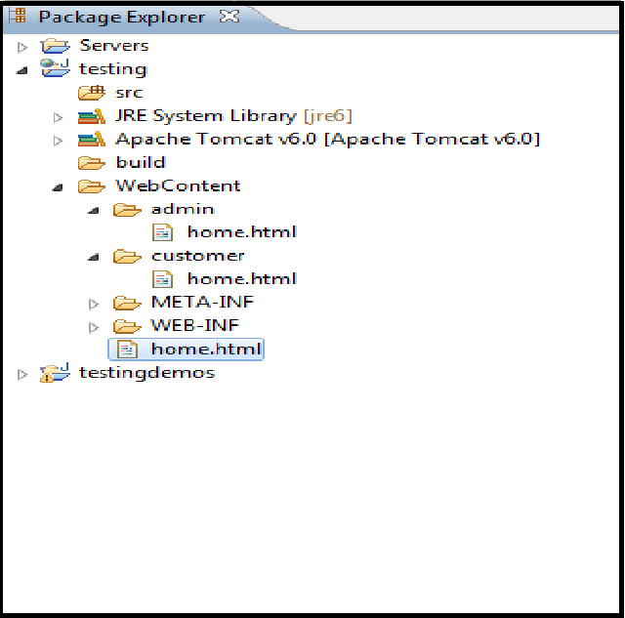

Welcome.html

<!DOCTYPE html PUBLIC "-//W3C//DTD HTML 4.01 Transitional//EN" "http://www.w3.org/TR/html4/loose.dtd">
<html>
<head>
<meta http-equiv="Content-Type" content="text/html; charset=ISO-8859-1">
<title>Welcome Page</title>
</head>
<body bgcolor="yellow">
<center>
<h1>Welcome Page Of Employee Web</h1>
<a href="admin/home.html">Admin Page</a><br>
<a href="employee/home.html">Employee Page</a><br>
</center>
</body>
</html>
admin/home.html

<!DOCTYPE html PUBLIC "-//W3C//DTD HTML 4.01 Transitional//EN" "http://www.w3.org/TR/html4/loose.dtd">
<html>
<head>
<meta http-equiv="Content-Type" content="text/html; charset=ISO-8859-1">
<title>Admin Page</title>
</head>
<body>
<center>
<h1>This is Admin Page</h1>
<a href="/employeeweb/welcome.html">Welcome Page</a><br>
<a href="">Add New Employee</a><br>
<a href="">Delete Existing Employee</a><br>
<a href="">View Employee Record</a><br>
<a href="">View All Employee Record</a><br>
</center>
</body>
</html>

employee/home.html

<!DOCTYPE html PUBLIC "-//W3C//DTD HTML 4.01 Transitional//EN" "http://www.w3.org/TR/html4/loose.dtd">
<html>
<head>
<meta http-equiv="Content-Type" content="text/html; charset=ISO-8859-1">
<title>Employee Page</title>
</head>
<body>
<center>
<h1>This is Employee Page</h1>
<a href="/employeeweb/welcome.html">Welcome Page</a><br>
<a href="">Update Your Profile</a><br>
<a href="">View Your Profile</a><br>
</center>
</body>
</html>

web.xml

<?xml version="1.0" encoding="UTF-8"?>
<web-app xmlns:xsi="http://www.w3.org/2001/XMLSchema-instance" xmlns="http://java.sun.com/xml/ns/javaee" xmlns:web="http://java.sun.com/xml/ns/javaee/web-app_2_5.xsd" xsi:schemaLocation="http://java.sun.com/xml/ns/javaee http://java.sun.com/xml/ns/javaee/web-app_2_5.xsd" id="WebApp_ID" version="2.5">

<display-name>employeeweb</display-name>
<welcome-file-list>
<welcome-file>welcome.html</welcome-file>
</welcome-file-list>

</web-app>

